PSY 301 Math Diagnostic Name: ________________________ Section: ______

You will not be graded on your performance on this diagnostic. The purpose of this activity is: (1) to get you back in the mode of working with numbers, (2) to get an idea of where everyone stands with regard to mathematics background, and (3) to see if there are any trouble areas that we should pay attention to in class. Your answers will not be graded, so please work on your own. You will receive 5 lab points for completing this activity.

Evaluate:
- | −4 | + | 4 | =
- 7 – (−2) =
- 4^{3/2} =
- 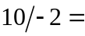
- 4! =
- 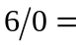
- (3/4) / 2 =
- (−4)² =
- 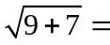
- 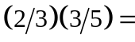
- {20 – 3[3 + 12 / 4]}² =
- If a = 3 and b = −1, a²b³ =
- 80% of 200 =
Round to two decimal places:
- 2.135 =
- 17.098 =
- 4.7736 =

Remove parentheses and simplify by combining like terms:
- 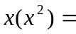
- 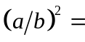
- x – (y + z) =
- (x – y)s + m =
- ns(1 – x)² =
Solve for x:
- 3x – 6 = 12
- 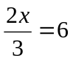
- 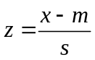
- y = bx + a

